GEOGRAPHY

GRADE 12 RESEARCH TASK 2022

This RESEARCH TASK consists of 9 pages.

GENERAL TIPS TO KEEP SAFE AND HEALTHY

1. | WASH YOUR HANDS thoroughly with soap and water for at least 20 seconds. Alternatively, use hand sanitizer with an alcohol content of at least 60%.
2. | PRACTICE SOCIAL DISTANCING – keep at least 1m away from other people.
3. | PRACTISE GOOD RESPIRATORY HYGIENE: cough or sneeze into your elbow or tissue and dispose of the tissue immediately after use.
4. | TRY NOT TO TOUCH YOUR FACE. The virus can be transferred from your hands to your nose, mouth, and eyes. It can then enter your body and make you sick.

INSTRUCTION AND INFORMATION
1. | Learners are not required to do field work
2. | THIS IS A DESKTOP RESEARCH TASK.  Desk research refers to secondary data or that which can be collected without fieldwork. To most people it suggests published reports and statistics, and these are certainly important sources. In the context of this chapter the term is widened to include all sources of information that do not involve a field survey.  Secondary research or desk research is a research method that involves using already existing data. Existing data is summarized and collated to increase the overall effectiveness of research. ... These documents can be made available by public libraries, websites, data obtained from already filled in surveys etc.  HOW TO CONDUCT A DESKTOP RESEARCH TASK  - Step 1: define the objective of your research. To search well, you have to know what you are looking for. ...  - Step 2: Define your research plan. Specifying your objective was a first (big) step towards the success of your desk research. ...  - Step 3: Conduct the research. ...  - Step 4: Conclude and verify the information.  METHODS OF COLLECTING DESK RESEARCH INCLUDE:  - Figures.  - newspapers.  - websites.  - government publications e.g. social trends.  - commercial publications e.g. Keynote and Mintel reports.

3. | Assessment:
 | Activities |  | Marks | Information Required | Length
 | Cover page |  | 5 | - Name & Surname  - Grade and Class  - Educator’s Name  - Subject  - Research Topic: The name of the Cyclone you are researching. | 1 A4 page
 | Index |  | 5 | - Numbers  - Topics  - Sub-topics  - Page numbers | 1 A4 page
 | Mapping |  | 10 | - World Map  - Satellite Images  - Map with path  - Annotated Diagram | 2 A4 pages
 | Introduction |  | 10 | - Brief introduction of tropical cyclones  - Sapphire-Simpson and Beaufort Scales | ½ A4 page
 | Discussions |  | 15 x 4 = 60 | Four paragraphs, with sub-topics | 2½ A4 pages
 | Conclusion/Summary |  | 5 |  | 10-12 lines on a 1 A4 page
 | Bibliography |  | 5 | Harvard method | Part of 1 A4 page
 | Total |  | 100 |  | 8 A4 pages

RESEARCH TOPIC:

THE DEVELOPMENT AND IMPACT OF TROPICAL CYCLONES

Guidelines for discussion

Choose ONE of the following Tropical cyclones:
- Hagibis
  - https://en.wikipedia.org/wiki/Typhoon_Hagibis
  - https://www.bbc.com/news/world-asia-50020108
  - https://www.theatlantic.com/photo/2019/10/scenes-aftermath-of-typhoon-hagibis/600040/

- Nivar
  - https://en.wikipedia.org/wiki/Cyclone_Nivar
  - https://www.business-standard.com/article/current-affairs/what-is-cyclone-nivar-logic-behind-the-name-and-things-you-need-to-know-120112400211_1.html
  - https://weather.com/en-IN/india/news/news/2020-11-25-why-nivar-heres-the-history-and-process-of-naming-the-devastating
- Ingrid
  - http://www.bom.gov.au/cyclone/history/pdf/ingrid.pdf
  - https://www.nhc.noaa.gov/data/tcr/AL102013_Ingrid.pdf
  - https://en.wikipedia.org/wiki/Cyclone_Ingrid
  - https://hardenup.org/umbraco/customContent/media/590_CapeYork_Cyclone_Ingrid_2005.pdf
- Florence
  - https://www.nhc.noaa.gov/data/tcr/AL062018_Florence.pdf
  - https://www.wunderground.com/cat6/Florence-Continues-Lash-Coastal-Carolina-Record-Surge-Beaufort-40-Rains-Possible
  - https://earthobservatory.nasa.gov/images/92757/the-complex-evolution-of-florences-winds
  - https://en.wikipedia.org/wiki/Hurricane_Florence#:~:text=An%20unexpected%20bout%20of%20rapid,(215%20km%2Fh).
- Eloise
  - https://reliefweb.int/disaster/tc-2021-000008-moz
  - https://public.wmo.int/en/media/news/tropical-cyclone-eloise-hits-mozambique
  - https://www.eumetsat.int/tropical-cyclone-eloise
  - https://www.ecotraining.co.za/tropical-cyclone-eloise/?gclid=Cj0KCQiAr5iQBhCsARIsAPcwROPn7W1Vnd8rgCVZJshCxK8UdhCD0CuyIP5QsMr4zu5wIqiG6VQQjNYaAk_YEALw_wcB
The desktop research must centre around ONE of the tropical cyclones.
Mapping:
- Find a world map, that indicate the regions where tropical cyclones develop.
- Plot the following Tropical cyclones next to the region where they originated on the world map. (Hagibis, Nivar, Ingrid, Florence and Eloise)
- Satellite image of the specific tropical cyclone under research.
- Map indicating the path of the tropical cyclone under research.
- Discuss the path of the tropical cyclone under research.
- Draw an annotated cross-section of a tropical cyclone in its mature stage. Indicate the following:
- Air movement
- Cumulonimbus clouds
- Eye and Eye wall
Introduction:

Introduce the tropical cyclone.
Use the Sapphire-Simpson and Beaufort scales to indicate the strength of the tropical cyclone.
Provide information about the Sapphire-Simpson and Beaufort scales.
Paragraph 1:

- Why do tropical cyclones develop in late summer?
- What is the impact of coriolis force and latent heat on the development of tropical cyclones?
- Discuss the stage of development of the tropical cyclone under research.
- Why can category 1 tropical cyclones be more destructive (damaging) than category 5 tropical cyclones

Paragraph 2:

How did the tropical cyclone impact the following?
- Environment
- Economy
- People/Communities
Paragraph 3:

What precautions can be implemented/ or has been implemented to reduce the impact of the tropical cyclone.
Refer to:
- The local government/Government of the country
- The local residents
Paragraph 4:

Evaluate the impact of Global Warming on the frequency (regularity) of tropical cyclones.
Conclusion/Summary:

Describe/Discuss your own views/experiences on the impact of tropical cyclones.

EXAMPLE OF SECONDARY RESOURCES:
TROPICAL CYCLONES ARE intense, spinning storm systems, with low-pressure centres that can be vast in size. They form over warm oceans and can wreak havoc when they approach the shore.
As the name suggests, tropical cyclones and hurricanes occur in the world’s tropics. They require the difference in speed of rotation of the Earth at different latitudes to gather momentum as they spin, and they can form either side of the equator.
Cyclones are called hurricanes in the Atlantic and eastern Pacific, typhoons in Southeast Asia, and cyclones in the Indian Ocean and western Pacific around Australia.
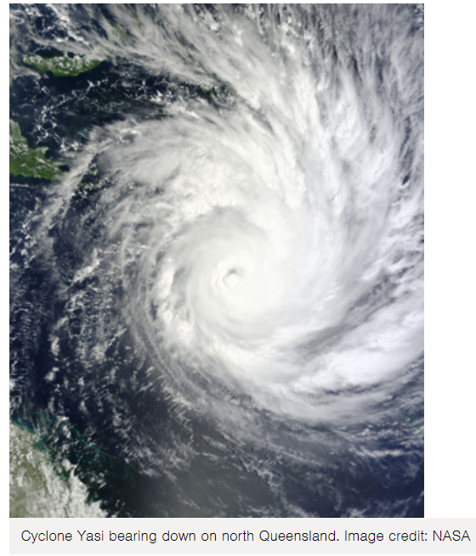

[Source: https://www.australiangeographic.com.au/topics/science-environment/2011/02/cyclones-facts-and-figures/]
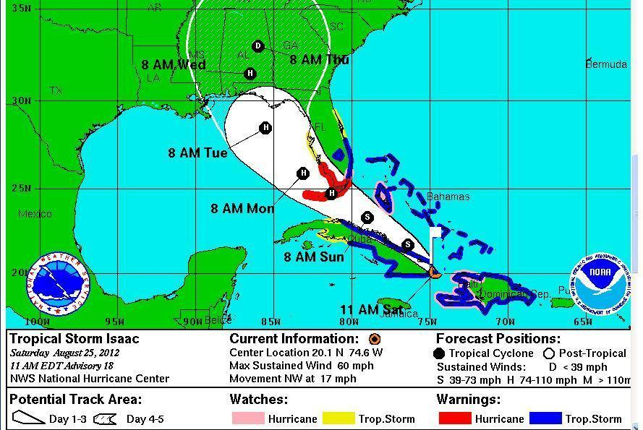  hURRICANES!  Ten Facts about Hurricanes!  1. Hurricanes are giant tropical storms that produce heavy rainfall and super-strong winds.  2. Hurricanes form over warm ocean waters near the equator. The warm, moist air above the ocean surface rises, causing air from surrounding areas to be “sucked” in. This “new” air then becomes warm and moist, and rises, too, beginning a continuous cycle that forms clouds. The clouds then rotate with the spin of the Earth. If there is enough warm water to feed the storm, a hurricane forms!  3. Hurricanes rotate around a circular centre called the “eye“, where it is generally calm with no clouds. Surrounding the eye is the eye wall – the most dangerous part of the hurricane with the strongest winds, thickest clouds and heaviest rain! | 4. Most hurricanes occur harmlessly out at sea. However, when they move towards land they can be incredibly dangerous and cause serious damage.  5. The strong spiralling winds of a hurricane can reach speeds of up to 320kmph – strong enough to rip up entire trees and destroy buildings!  6. In the southern hemisphere, hurricanes rotate in a clockwise direction, and in the northern hemisphere they rotate in an anti-clockwise direction. This is due to what’s called the Coriolis Force, produced by the Earth’s rotation.  7. When a hurricane reaches land it often produces a “storm surge“. This is when the high winds drive the sea toward the shore, causing water levels to rise and creating large crashing waves. Storm surges can reach 6m high and extend to over 150km!  8. Hurricanes are also called cyclones and typhoons, depending on where they occur. In the Atlantic Ocean and Northwest Pacific they are hurricanes, in the Northwest Pacific they are typhoons and in the South Pacific and Indian Ocean they are cyclones.  9. The largest hurricane on record is Typhoon Tip, which occurred in 1979 in the northwest Pacific. With a diameter of around 2,220km, it was nearly half the size of the United States!  10. Hurricanes are given names by the World Meteorological Organisation (WMO) so that they can be distinguished. Each year, tropical storms are named in alphabetical order according to a list produced by the WMO. That name stays with the storm if it develops into a hurricane. The names can only be repeated after six year.  [Source: https://www.natgeokids.com/za/discover/geography/physical-geography/hurricanes/]

Hurricane Irma Facts, Damage, and Costs

Irma damage could have been $300 billion if it hit Miami.

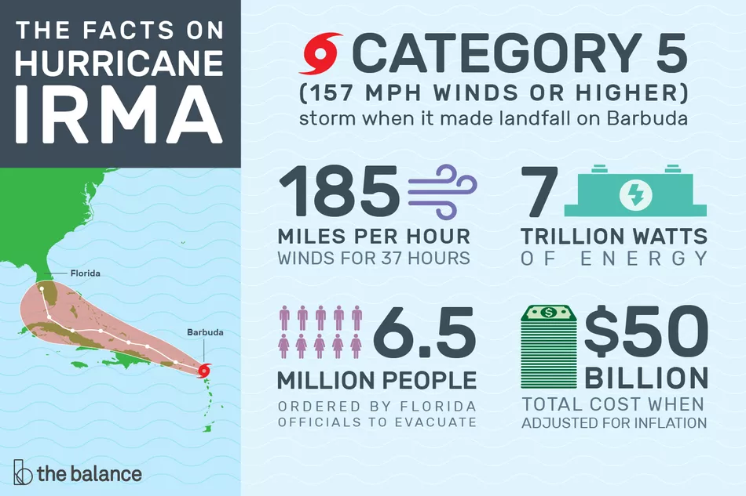  Hurricane Irma was one of the most powerful Atlantic hurricanes in recorded history. It was a Category 5 storm when it made landfall on Barbuda on September 6, 2017. Its winds were 185 miles per hour for 37 hours.﻿﻿﻿﻿﻿ An unofficial wind gust was clocked at 199 miles per hour. These winds extended 50 miles from the center.  Tropical-storm-force winds extended 185 miles from the center. Its coastal storm surges were 8 feet above normal tide levels. Above-average ocean temperatures of 86 degrees Fahrenheit sustained the storm.﻿﻿﻿﻿ These temperatures are worsening due to global warming.  Irma held 7 trillion watts of energy. That's twice as much as all bombs used in World War II. Its force was so powerful that earthquake seismometers recorded it. It generated the most accumulated cyclone energy in a 24-hour period.  Irma's attack was the first time in 100 years that three storms Category 4 or larger hit the U.S. or its territories in the same year. Hurricane Harvey devastated Houston on August 25, 2017, and Hurricane Maria hit Puerto Rico on September 20. | Timeline  President Trump declared emergencies in Florida, Puerto Rico, and the U.S. Virgin Islands. On September 6, Florida's governor ordered residents of the Keys to evacuate.  - September 6, 2017: Irma hit the Leeward Islands with winds over 180 miles per hour. The Prime Minister of Antigua and Barbuda described Barbuda as "barely habitable."  - September 7: Irma left hundreds in Puerto Rico without power. It hit the northern part of Haiti and the Dominican Republic with 15 inches of rain.  - September 8: Irma remained a Category 5 hurricane with a wind of 175 miles per hour. It affected the Turks and Caicos Islands and the eastern Bahamas. The storm passed over waters warmer than 86 degrees Fahrenheit. Barbuda's government issued a watch for Hurricane Jose.  - September 9: Irma affected the north coast of Cuba, flooding Havana. Winds hit approximately 150 miles per hour and waves reached up to 36 feet. Wind gusts of 55 miles per hour hit southeast Florida. The storm was downgraded to a Category 3 but was projected to regain strength before hitting Florida.  - September 10: Irma was upgraded to a Category 4. It hit Cudjoe Key, 20 miles north of Key West, and then Naples. Miami didn't get the core of Irma but still received life-threatening conditions. The Florida Keys received approximately 12 inches of rain and a 10-foot storm surge. Rainfall averaged 10 to 15 inches.  - September 11: Irma was downgraded to a Category 1 hurricane as it headed to Tampa, where it left 12 million people without power. Irma was then downgraded to a tropical storm as it hit Georgia, where 1.5 million lost power. The state had ordered people to begin evacuating on September 9.

The Facts on Hurricane Irma's Damage
Irma's death toll included 129 people in Florida, Georgia, and North Carolina. Florida officials ordered over 6.5 million people to evacuate.⁷﻿﻿﻿﻿﻿﻿ The Red Cross reported more than 550,000 overnight shelter stays related to the hurricane.
Irma damaged 95% of the buildings on Barbuda. It destroyed almost all communication and left much of the island uninhabitable. Many of its residents fled to Antigua.
Irma's total cost to the U.S. alone was $50 billion when adjusted for inflation. If such a storm were to hit Miami, the damage could reach $300 billion, according to insurance firm Swiss Re in a report examining the damage caused by 1992's Hurricane Andrew.⁹﻿﻿﻿﻿﻿﻿﻿﻿
Irma threatened losses of up to $2.5 billion for Florida's agricultural produce.¹⁰The state is America's second-largest grower of vegetables like tomatoes, green beans, and cucumbers. The potential shortage pushed orange juice futures and sugar prices higher in the days leading up to the storm. If Irma had hit Georgia and the Carolinas hard enough, it would have affected corn, soybeans, cotton, and peanut prices.
Fort Pierce, Florida, received 21.66 inches of rain, the most in the state. The strongest winds at 142 miles per hour hit Naples. ﻿﻿﻿﻿ Winds were 73 miles per hour in Miami. ﻿﻿﻿﻿ Three cranes collapsed, and streets flooded.
Miami-Dade, Monroe, and Broward counties' building codes have the nation's highest wind standards. They improved their preparation after Hurricane Andrew hit in 1992. But that might not offer enough protection as hurricanes grow more powerful. “There’s no structure in Miami that’s built to withstand 185 mph winds,” Keith Wolfe, president of U.S. property and casualty for Swiss Re, told the Miami Herald.
As The New York Times reported, roughly 70% of the region’s buildings were built before 1994. Many of them have not been retrofitted. Even high-rises built to higher wind codes will suffer from heavy rains that seep in through roofs.
Irma could have done more damage, but Florida learned from Hurricane Charley in 2004 and Hurricane Andrew in 1992. The state revamped building codes to make houses more resilient to hurricanes. As a result, 80% of the homes in Irma's path were built to better withstand the storms.¹²﻿﻿

3 Ways Climate Change Made Irma Worse
Climate change contributed to Irma's impact in three critical ways. First, rising sea levels worsened storm surges and flooding. Between 1880 and 2015, the average global sea level rose 8.9 inches.¹⁴﻿﻿﻿﻿﻿﻿﻿ For perspective, Swiss Re estimates that a 3.34-inch rise in sea level could nearly double the costs of damages from hurricane-related storm surges.
Second, South Florida’s average August 2017 temperature was four-tenths of a degree above normal. Miami's average temperature for August was the warmest during that period on record, and temperature records were broken across the state. Seven of the past 10 summers have been above normal.
Warmer air holds more moisture, leading to greater build-up leading up to a storm. When this warm air releases the moisture, the water falls in torrents. This creates greater rainfall during a hurricane.
Third, global warming slows weather patterns. It allows hurricanes to hover over an area longer. In fact, storms have slowed down by 10% since 1949.¹⁷﻿﻿﻿﻿﻿﻿ This is caused by a weakened jet stream—a river of wind high in the atmosphere that races from west to east at speeds up to 275 miles an hour. It undulates north and south as it goes, driven by temperature contrasts between the Arctic and temperate zones. Since the Arctic is warming faster than the rest of the globe, it slows down the jet stream, allowing storms like Irma to move much slower than normal and wreak more havoc as they linger. ﻿﻿﻿﻿﻿﻿
MIT models foresee more hurricanes developing from climate change in the decades ahead. ﻿﻿﻿﻿ Extreme storms with winds above 190 miles per hour are likely to form. That is more powerful than a Category 5, leading many meteorologists to call for a Category 6 designation.

How Irma's Damage Compares to Other Hurricanes
Irma was one of the most powerful Atlantic hurricanes, but it was not the most destructive because it skipped the most developed cities in Florida.

.

RUBRIC FOR RESEARCH TASK:
LEARNER: | Name: __________________________________________________
 | Surname: _______________________________________________
GRADE: | 12 _______
DISCUSSION TOPIC: | ________________________________________________________
 | ________________________________________________________
 | Educator Total Moderator Total
Criteria | Marks
Cover page | 1 |  | 2 |  |  |  |  |  |  |  | 3 |  |  |  |  | 4-5 |  |  |  |  |  | Educator Mark |  |  | Moderator mark
 | Poor attempt  - Name and surname |  | Most relevant information  - Name and surname  - Grade  - Topic |  |  |  |  |  |  |  | Most relevant information  - Name and surname  - Grade  - Topic  - Colourful and effort |  |  |  |  | All required information  - Name & Surname  - Grade and Class  - Educator’s Name  - Subject  - Research Topic: The name of the Cyclone you are researching.
Index | 0 |  |  |  | 1 |  |  |  |  |  |  | 2-3 |  |  |  |  |  |  | 3-5 |  |  |  | Educator Mark |  |  | Moderator mark
 | No Index |  |  |  | Content noted without page numbers |  |  |  |  |  |  | - Content with page numbers  - Sequencing incorrect |  |  |  |  |  |  | - Content with page numbers  - Sequencing correct
Mapping

 | 1-2 | 3-4 |  |  |  |  |  |  | 5-6 |  |  |  |  | 7-8 |  |  |  |  |  | 9-10 |  |  | Educator Mark |  |  | Moderator mark
 | - World map without plotting of the cyclones.  - Satellite image | - World map with cyclones plotted.  - Satellite image  - Map indicating the area, without the path |  |  |  |  |  |  | - World map with cyclones plotted.  - Satellite image  - Map indicating the path.  - Discussing the path of the tropical cyclone |  |  |  |  | - World map with cyclones plotted.  - Satellite image  - Map indicating the path.  - Discussing the path of the tropical cyclone  - Cross-section without annotations |  |  |  |  |  | - World map with cyclones plotted.  - Satellite image  - Map indicating the path.  - Discussing the path of the tropical cyclone  - Cross-section with annotations
Introduction | 1-2 | 3-4 |  |  |  |  |  |  | 5-6 |  |  |  |  | 7-8 |  |  |  |  |  | 9-10 |  |  | Educator Mark |  |  | Moderator mark
 | - Vague and disjointed introduction  - No Specifics | - Specific introduction about discussion point and topic  - Indicating the Sapphire-Simpson and Beaufort scales |  |  |  |  |  |  | - Specific introduction about discussion point and topic  - Indicating the Sapphire-Simpson and Beaufort scales, with indication of the strength of the tropical cyclone |  |  |  |  | - Specific introduction about discussion point and topic  - Indicating the Sapphire-Simpson and Beaufort scales, with indication of the strength of the tropical cyclone  - Information about Sapphire-Simpson scale without the Beaufort scale |  |  |  |  |  | - Specific introduction about discussion point and topic  - Indicating the Sapphire-Simpson and Beaufort scales, with indication of the strength of the tropical cyclone  - Information about Sapphire-Simpson scale with the Beaufort scale
Body/Paragraphs | 1-3 | 4-6 |  |  |  |  |  | 7-9 |  |  |  |  |  | 10-12 |  |  |  |  |  | 13-15 |  |  | Educator Mark |  |  | Moderator mark
 | - At least ONE paragraph relevant  - Very poorly researched with minimum effort  - No integration of information from different sources  - Evident that only one source has been used | - At least TWO paragraphs relevant  - Information from different sources is haphazardly integrated.  - Listing of points  - No solutions and interventions provided |  |  |  |  |  | - Each paragraph has relevant information.  - Information from different sources is poorly integrated.  - At least four points per paragraph discussed.  - No solutions and interventions provided |  |  |  |  |  | - Each paragraph thoroughly constructed.  - Different source’s Information per paragraph is properly integrated.  - Points per paragraph discussed.  - Names of presenters/writers/reporters/  journalists not accredited.  - Limited solutions and interventions provided.  - Drawing done with annotation  - Some paragraphs have sketches, statistics, pictures, etc. to illustrate the discussion. |  |  |  |  |  | - Each paragraph thoroughly constructed.  - Different source’s Information per paragraph is properly integrated.  - Points per paragraph thoroughly discussed.  - Names of presenters/writers/reporters/  journalists accredited.  - Extensive solutions and interventions provided.  - Annotated drawing done.  - All paragraphs have sketches, statistics, pictures, etc. to illustrate the discussion. |  |  | P1 |  |  | P1
 |  |  |  |  |  |  |  |  |  |  |  |  |  |  |  |  |  |  |  |  |  |  | P2 |  |  | P2
 |  |  |  |  |  |  |  |  |  |  |  |  |  |  |  |  |  |  |  |  |  |  | P3 |  |  | P3
 |  |  |  |  |  |  |  |  |  |  |  |  |  |  |  |  |  |  |  |  |  |  | P4 |  |  | P4
 |  |  |  |  |  |  |  |  |  |  |  |  |  |  |  |  |  |  |  |  |  |  | Tot |  |  | Tot
Conclusion | 0 |  |  |  |  | 1 |  |  |  |  |  |  | 2-3 |  |  |  | 4-5 |  |  |  |  |  | Educator Mark |  |  | Moderator mark
 | No conclusion |  |  |  |  | Own views are very vaguely discussed. |  |  |  |  |  |  | Own views are discussed, with some background |  |  |  | Own views are discussed, with background.  Conclusion also have a brief summary of the development and impact of tropical cyclones
Bibliography | 0 |  |  |  |  |  | 1-3 |  |  |  |  |  |  |  |  |  |  | 4-5 |  |  |  |  | Educator Mark |  |  | Moderator mark
 | No sources accredited |  |  |  |  |  | At least THREE sources from the internet accredited |  |  |  |  |  |  |  |  |  |  | - At least THREE sources from the internet accredited  - Also, books/articles used.  - Harvard method used.

